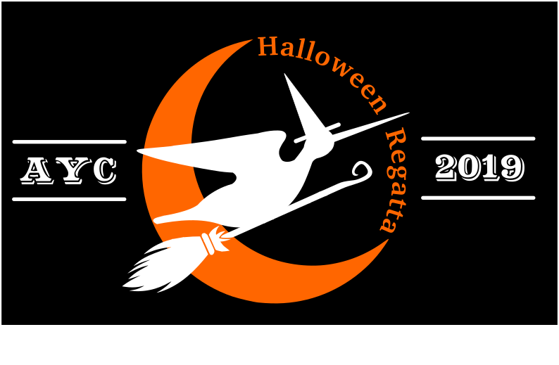
~2019 SNIPE HALLOWEEN REGATTA~

FRIDAY – October 25

6:00 - 9:00 pm Halloween Regatta Registration at the Club House
6:00 - 8:00 pm Complimentary Chili Dinner: traditional chili, veggie options, white chili, and some other more mysterious options. See desert option below - Jr Fundraiser Smores
6:30 - 7:30 pm Children’s Halloween Party
7:30 - 8:00 pm Children’s Trick or Treating
7:30 - 9:00 Smores Jr. Fundraiser ($1 a kit, donations are appreciated)
9:00 - ?? pm Acoustic Guitar Gathering in Adult Lounge – Bring your instruments and join in

SATURDAY – October 26
7:30 - 9:30 am Complimentary Breakfast: AYC Club House
8:00 - 10:30 am Halloween Regatta Registration: AYC Club House
9:00 am Junior Competitor Meeting: Pavilion at the point
9:30 am Start Sequence for First Junior Race
11:00 am Competitors meeting: Pavilion at the point.
11:30 - 12:30 pm Lunch of soup, sandwiches, chips, cookies & drink
1:30 pm Warning signal for 1st race of day, 2nd race to follow
We welcome sailors back from an afternoon of races with the traditional Halloween Hot Buttered Rum.
Join us at the Point!

6:30 pm Complimentary Appetizers.
7:00 pm Children’s dinner -Sloppy Joes with Mac n’ cheese.
7:30 pm Dinner: Chicken Kabobs, Roast Lamb Shank or Falafel for vegetarian option with savory rice, humus, fresh warm pita, tabbouleh & Greek salad - Catered by Jerusalem Bakery
8:30 - 11:30 pm Halloween Party Hoedown … DJ Michael Guebert and Costume Competition and dancing!

SUNDAY – October 27
7:30 - 9:00 am Complimentary Grab n’ Go Breakfast: AYC Club House
9:30 am Warning Signal for 1st race of day
12:30 pm Grilled Hamburgers and Leftovers Lunch: Followed by Awards Ceremonies.
